System Analysis & Design Methodologies

Version 1.1.0

**Version Control**

|  |  |  |
| --- | --- | --- |
| **Date** | **Reason of change** | **Author** |
| 19/12/2018 | Document submitted | C. Rodrigo |
| 19/12/2018 | Document reviewed | B. Corcoran |
| 21/12/2018 | Document revision and correction | C. Rodrigo |
|  | Conclusion section has been extended to include my complete point of view about the main topic. | C. Rodrigo |
|  | Harvard referencing has been implemented, including image sources and bibliography | C. Rodrigo |
| 5/02/2019 | Added Appendix about Agile Methodologies | C. Rodrigo |
|  | Added table of figures and figures bibliography | C. Rodrigo |
|  | Added Appendix about Business Intelligence | C. Rodrigo |
|  |  |  |
|  |  |  |
|  |  |  |
|  |  |  |
|  |  |  |

**Author**: Carlos Rodrigo

**Title**: System Analysis & Design Methodologies

**Lecturer**: Barbara Corcoran

**BTEC Units**:

**Date**: 20 December 2018

**Remarks**: N/A

Contents

Table of Figures 3

Introduction 4

Waterfall 4

Parallel Development 5

V-Model 6

Interactive Development 7

System Prototyping 7

Throwaway Prototyping (Selected!) 8

Agile 10

Agile VS Waterfall-Based Methodologies 10

Selection Summary 11

Conclusion 12

Image Sources 12

Bibliography 13

Appendix 1 – Agile Methodologies 14

Overview 14

Agile Manifest 14

The most popular agile methodologies 15

Scrum 15

Scrum Main Characteristics 16

Extreme Programming (XP) 16

XP Main characteristics 17

Kanban 17

Kanban Main Characteristics 18

Other Agile methodologies 19

Agile Methodologies Software Tools (SCRUM) 20

Image Sources 21

Bibliography 22

Appendix 2 – Business Intelligence (BI) 23

Overview 23

BI History 23

Advantages of Business Intelligence tools 23

Business Intelligence Tools 23

Bibliography 25

## Table of Figures

Figure 1: The Waterfall process diagram 4

Figure 2: Parallel Development diagram from System prototyping diagram from System Analysis and Design Sixth Edition. Boston: Wiley, pp.40-46 5

Figure 3: V-Model diagram from System prototyping diagram from System Analysis and Design Sixth Edition. Boston: Wiley, pp.40-46 6

Figure 4: Interactive Development diagram from System prototyping diagram from System Analysis and Design Sixth Edition. Boston: Wiley, pp.40-46 7

Figure 5: System prototyping diagram from System Analysis and Design Sixth Edition. Boston: Wiley, pp.40-46 8

Figure 6: Throwaway Prototyping from System prototyping diagram from System Analysis and Design Sixth Edition. Boston: Wiley, pp.40-46 9

Figure 7: SCRUM Diagram from Jordan Job website 16

Figure 8: Extreme Programming Process Cycle by tutorialspoint.com 17

Figure 9: Kanban Board Example by leankit.com 18

## Introduction

There are many methodologies. The first challenge faced by project managers is to select which methodology to use.

## Waterfall

In this methodology, analysts and users moves sequentially from one phase to the next.

The deliverables for each phase are typically voluminous and are presented to the approval committee as the project moves from phase to phase.

Once the work produced and approved, the phase ends and the next phase begins.

As the project progresses from one phase to the next one, it moves forward like a waterfall.

Waterfall development methodologies have the advantages of identifying requirements long before programming begins and limiting changes to the requirements as the project proceeds.

The key disadvantages are that the design must be completely speciﬁed before programming begins.

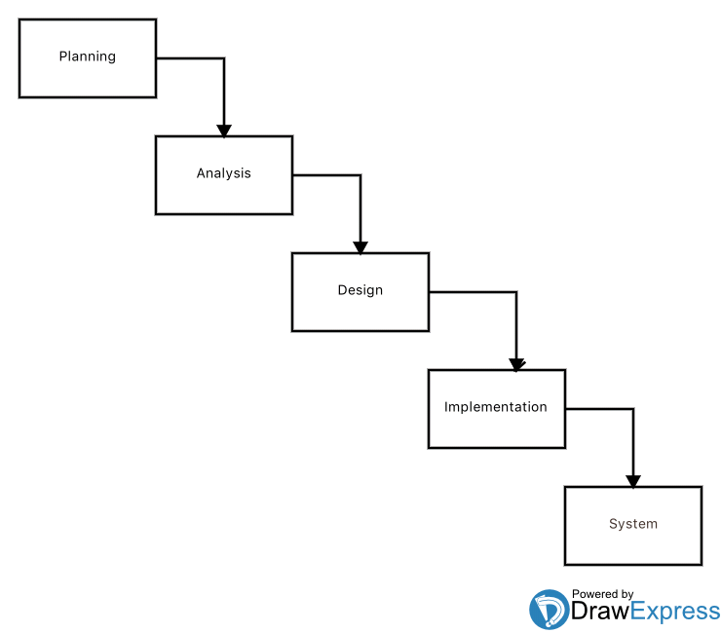

Figure 1: The Waterfall process diagram

## Parallel Development

It evolved to reduce the time frame of waterfall. instead of doing the design and then the implementation, a general design for the whole system is performed.

Then the project is divided into a series of sub-projects that can be designed and implemented in parallel.

Once all sub-projects are complete, there is a ﬁnal integration of the separate pieces, and the system is delivered.

The approach still suffers from problems caused by voluminous deliverables.

It also adds a new problem: If the sub-projects are not completely independent, design decisions in one subproject may affect another, so, integrating the sub-projects may be quite challenging.

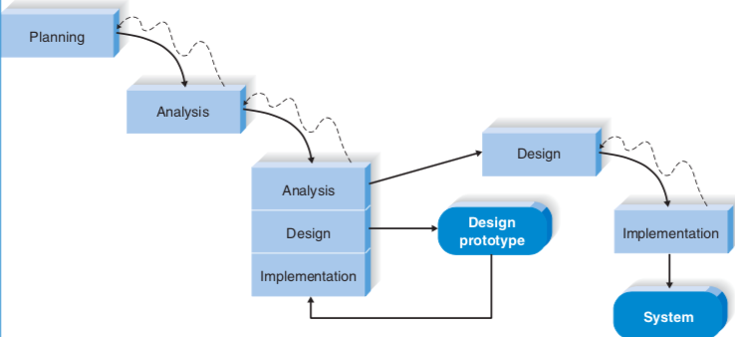

Figure 2: Parallel Development diagram from System prototyping diagram from System Analysis and Design Sixth Edition. Boston: Wiley, pp.40-46

## V-Model

Another variation of waterfall development that pays more attention to the tests that the previous methodologies I have presented in this document so far.

The development process goes down the left-hand slope of the V, deﬁning requirements and designing system components.

At the base of the V, the programs’ code is written. On the upward-sloping right side of the model, testing of components, integration testing, and then acceptance testing is performed.

A main concept is that as requirements are speciﬁed and components designed, and tests are also deﬁned at same time.

So, each level of testing is clearly linked to a part of the analysis or design phase, helping to ensure high quality testing and to maximize test effectiveness.

The V-model is simple and improves the overall quality of systems through its emphasis on early development of tests.

It still suffers from some rigidity of the waterfall methodology.



Figure 3: V-Model diagram from System prototyping diagram from System Analysis and Design Sixth Edition. Boston: Wiley, pp.40-46

## Interactive Development

Beaks the overall project into a series of versions that are developed sequentially.

The most important requirements are bundled into the ﬁrst version, which is developed quickly by a mini-waterfall process, and once implemented, users can provide valuable feedback.

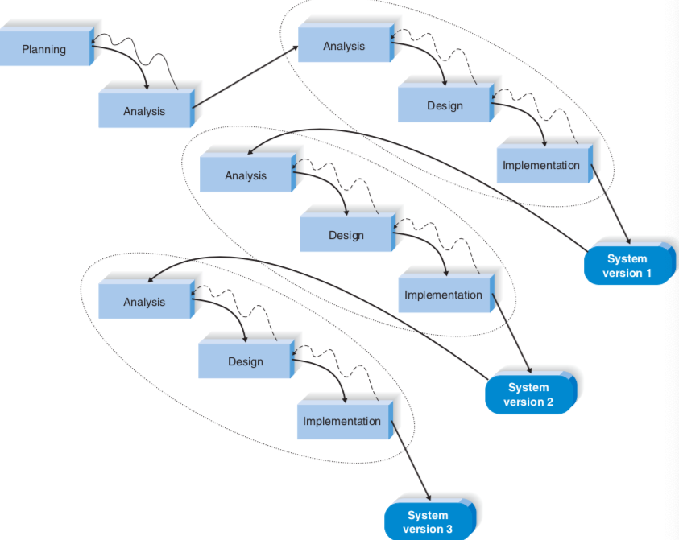

Figure 4: Interactive Development diagram from System prototyping diagram from System Analysis and Design Sixth Edition. Boston: Wiley, pp.40-46

Since users are working with the system, important additional requirements may be identiﬁed.

The main disadvantage is that users begin to work with a system that is intentionally incomplete.

Users must accept that only the most critical requirements of the system will be available in the early versions.

## System Prototyping

Performs the analysis, design, and implementation phases concurrently in order to quickly develop a simplified version of the proposed system and give it to the users for testing and feedback ASAP.

The system prototype is a version of a given new system with minimal functionality.

Following reaction and comments from the users, the developers reanalyze, redesign, and reimplement a second prototype that corrects deﬁciences.

This cycle continues until the analysts and users agree that the prototype provides enough functionality.

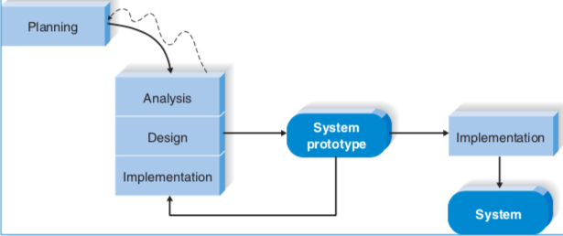

Figure 5: System prototyping diagram from System Analysis and Design Sixth Edition. Boston: Wiley, pp.40-46

## Throwaway Prototyping (Selected!)

Includes the development of prototypes too but uses them primarily to explore design alternatives rather than as the actual new system, like in system prototyping.

Many of the features suggested by the users may not be well understood and challenging technical issues may arise. Each of these issues is carefully examined by analyzing, designing, and building a design prototype. A design prototype is not intended to be a fully functional system. It only contains enough functionality to enable users to understand the issues under analysis or consideration.

For example, suppose that lecturers are not completely clear on how the registering system should work. The analyst team might build a series of mobile apps to be used on an iPad to help the users visualize such a system.

In this case, a series of “mocked” screens are proved for testing, but they really do nothing.

Figure 6: Throwaway Prototyping from System prototyping diagram from System Analysis and Design Sixth Edition. Boston: Wiley, pp.40-46

## Agile

There are several popular approaches to agile development, like extreme programming (XP) SCRUM, and Dynamic System Development Method (DSDM), but here I’m only to briefly describe extreme programming, which is one of the methodologies that I had considered to adopt for the project. I had some experience recently with XP as well.

Extreme Programming emphasizes customer satisfaction, teamwork, frequent communication, simplicity and lots of feedback are core values. Developers communicate with final users, a remarkable property of XP.

Design are kept simple and clean. Early and frequent testing provides feedback and developers can courageously respond by changing requirements and technology. XP project teams are small.

An XP project begins with user stories that describe what the system should to do. User histories are small text paragraphs which describes briefly a concrete problem or need. Then, programmers code in small modules (and test) to meet those user stories requirements. Users are required to be available to clear up questions as they arise.

## Agile VS Waterfall-Based Methodologies

Agile development approaches have existed for about two decades. They were created in part because of dissatisfaction with the sequential and inflexible structure of waterfall-based approaches.

Presently, agile development has made inroads into software development organizations, and studies show an even split between agile and waterfall users.

Please **see Appendix 1** for further information.

## Selection Summary

| Ability to develop system | Waterfall | Parallel | V-Model | Iteractive | Sys. Proto | Throwaway Prototyping | Agile |
| --- | --- | --- | --- | --- | --- | --- | --- |
| With unclear  User requirements | Poor | Poor | Poor | Good | Excellent | Excellent | Excellent |
| With unfamiliar technology | Poor | Poor | Poor | Good | Poor | Excellent | Poor |
| That are complex | Good | Good | Good | Good | Poor | Excellent | Poor |
| That are reliable | Good | Good | Excellent | Good | Poor | Excellent | Good |
| With a short Tim schedule | Poor | Good | Poor | Excellent | Excellent | Good | Excellent |
| With a schedule visibility | Poor | Poor | Poor | Excellent | Excellent | Good | Good |

Source: *System Analysis and Design Sixth Edition*

## Conclusion

**The selected methodology is:** Throwaway Prototyping.

Without years of experience in software Analysis with different technologies, I can’t find myself in the position of making a choice properly. Methodology selection is a really complex task.

I think that the choice depends more on the context in which a certain project is going to be developed, that is, the development team, the type of project, the type of client, etc. The choice can be tilted from one side or the other by matters as apparently irrelevant as the character and way of working of the members of the team that one has around.

Therefore, I believe the human factor plays a critical role in the choice of the methodology.

Why? Because there are a lot of human interaction involved on the process. Technical skills like programming, database design, etc. are almost irrelevant there.

And when I say this, I mean that the person responsible for the election must know the team around him very well. This person must know the company thoroughly, and for this, it is essential that he/she have at least one or two years of working experience into the organization, in order to make a wise methodology choice.

In the other hand, most companies have been developed their own methodologies along the years. And these are composed from pieces and concepts from others.

Said that, I will try to simplify my view to make a quick choice, based on an ideal and hypothetical project, working environment and client.

Apparently, the perfect methodology for this project is Throwaway Prototyping.

One important item in this project, is the degree of experience in mobile app development of the College IT Team. So, will be necessary to perform numerous prototypes and tests before having the 1st beta version.

The app prototypes can be very useful to increase the number of functionalities asked by the Lecturers, when they proceed to test the apps.

The system will be very simple, so we don’t need the facilities that waterfall methodology offers to deal with complex systems.

## Image Sources

Alan Dennis, Roberta M. Roth, S, Barbara Harley Wixom (2014). *System Analysis and Design Sixth Edition*. Boston: Wiley, pp.40-46.

## Bibliography

Alan Dennis, Roberta M. Roth, S, Barbara Harley Wixom (2014). *System Analysis and Design Sixth Edition*. Boston: Wiley, p.47.

Intro to Scrum in Under 10 Minutes [Online] *Axosoft (YouTube*) Available from:

https://www.youtube.com/watch?v=XU0llRltyFM

[Accessed 12 December 2018]

Agile Vs Waterfall - Four Massive Differences [Online] *Database Star (YouTube*) Available from:

https://www.youtube.com/watch?v=_U7Py7W-Qng

[Accessed 13 December 2018]

What is V Model Advantages Disadvantages and when to use it [Online] *LearnEveryone (YouTube*) Available from:https://www.youtube.com/watch?v=jPdfDGIyQ40

[Accessed 13 December 2018]

Evolutionary Prototyping Process - Georgia Tech - Software Development Process [Online] *Udacity (YouTube*) Available from:https://www.youtube.com/watch?v=bAEnaGG8Otc

[Accessed 09 December 2018]

What is Agile? [Online] *Mark Shead (YouTube*) Available from:

https://www.youtube.com/watch?v=Z9QbYZh1YXYQng

[Accessed 12 December 2018]

Scrum vs Kanban - Two Agile Teams Go Head-to-Head + FREE CHEAT SHEET [Online] *Development That Pays (YouTube)* Available from: <https://www.youtube.com/watch?v=HNd1_irOL5k>

[Accessed 10 December 2018]

## Appendix 1 – Agile Methodologies

### Overview

The world of software development has evolved from a model in which all stages are carefully planned and structured, a model in which development should be faster and more efficient as possible.

### Agile Manifest

1. Like any other methodology, it has a series of principles to be respected when applying it. These principles are:
2. The highest priority is the client's satisfaction, by early and continuous delivery.
3. Changes in requirements will be welcome, even when they are late.
4. Make frequent deliveries, from a couple of weeks to a couple of months.
5. Business analyst and developers must work daily and closely.
6. Team members should be motivated and should receive the support and confidence that they need. The work environment must be pleasant.
7. The preferred communication method should be face-to-face conversation.
8. The software already encoded is the main measure of progress.
9. Agile processes promote sustainable development.
10. Sponsors, developers and users should be able to
11. Maintain a constant rhythm indefinitely.
12. Continuous attention in technical excellence.
13. Simplicity is very important
14. The best architectures, requirements and designs arise in self-organized teams.
15. Hold meetings regularly and frequently in order to find ways to be more effective.

You can read such a manifest at: <https://agilemanifesto.org/principles.html>

### The most popular agile methodologies

The most used agile methodologies nowadays are the following:

1. SCRUM
2. Xtreme Programming (XP)
3. Kanban

Below I will briefly explain these 4 methodologies.

### Scrum

It is the most popular agile methodology.

SCRUM Emphasizes incremental development (a strategy that consists of developing specialized software to respond to the weaknesses of the traditional cascade model), leaving behind the planning phase.

SCRUM focuses on knowing a detail to the people who are part of a self-organized team instead of investing time investigating the quality of the processes used, as well as guaranteeing the quality of the result.

Some people call it as "the methodology of chaos" because it supports the theory that all processes tend to be chaotic by nature.

Once that nature is accepted, SCRUM proposes a strategy to manage the chaos and not eliminate it completely.

SCRUM also puts the eye to the different phases of development, as well as being dedicated to having an accurate vision of what the client is looking for.

In SCRUM there are cicles or (people) interactions called “sprints” which are repeated continuously until the client decides that the evolution of the product has already been closed.

These interactions respond to the construction of the product in incremental form, which will do precisely through such interactions.

### Scrum Main Characteristics

1. Incremental life-cycle
2. Continuous revisions by the development team
3. 15 minutes long daily meeting, 15 min. duration as max.
4. Finally, when the project ends, final review of every single sprint

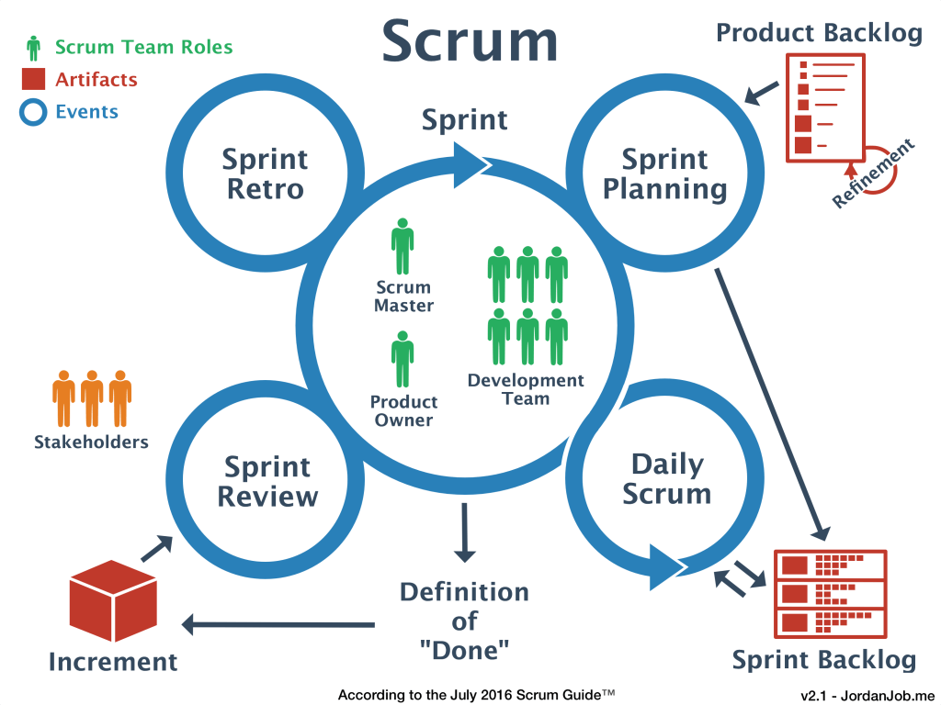

Figure 7: SCRUM Diagram from Jordan Job website

### Extreme Programming (XP)

Extreme Programming is an agile method that is usually used in teams with just a few programmers who have very few processes open at the same time.

It consists mainly of designing, implementing, programming and implementing as quickly as possible teams of very small programmers, mainly couples, skipping documentation and traditional procedures from older methodologies.

It is based on the ability of the team to communicate with each other, and the desire to learn from the programming inherent errors.

The great advantage of this system is the team's incredible capacity to respond to unforeseen events, although it is a methodology that is difficult to document.

XP is a great method for small teams that focus on a single client.

### XP Main characteristics

1. People and collaboration are the main factors
2. Its concentrates in make the software to work, before make any documentation
3. Its very flexible and assumes changes very well
4. Its planning is very flexible as well
5. The team tents to divide the work in small actions
6. It is client focused, so the client is on command about every single development.

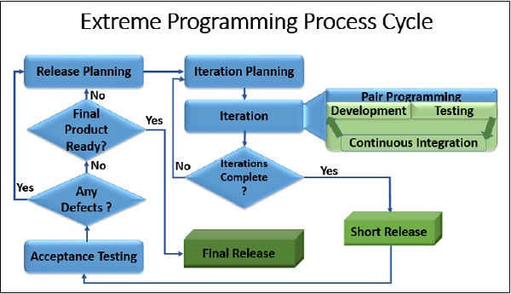

Figure 8: Extreme Programming Process Cycle by tutorialspoint.com

### Kanban

This methodology has become popular because it is applied by Trello, a project management program.

Kanban is a Japanese word that responds to the meaning "visual cards".

It is also known as "card system", because it makes use of these so that the company and its employees can be aware of the processes that are taking place within the company and can regulate their flow, that is, limit the work ongoing to be done more productively: if a task has not been completed, you should not start another.

The technique was created by Toyota and since then it is used by many companies around the world to keep a detailed control of the progress made in their projects.

Currently, Kanban is one of the preferred methodologies in software project management.

### Kanban Main Characteristics

1. It represents all the information of the Project in a very visual way.
2. Is based on WIP (Work in Progress) a very simple idea.
3. Uses a three task columns diagram: TODO, DOING and DONE. That’s it.
4. Every single team member can access to the diagram, which is great to promote or facilitate the work-flow.
5. No task starts before the previous one has been completed.

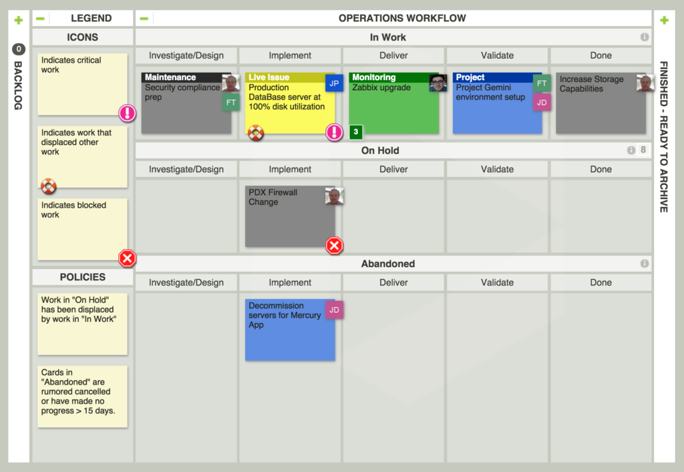

Figure 9: Kanban Board Example by leankit.com

There is an evolution from Kanban, called “Lean”.

It mainly consists of incremental software evolution cycles in which the decisions are postponed as much as possible until we have obtained feedback from the client and thus react as quickly and efficiently as possible to their needs.

It is based on having a powerful and committed team and the principle of continuous learning about the product.

it is a fantastic methodology for startups that are developing software oriented to succeed in the market, such as video games or mobile apps.

### Other Agile methodologies

* Adaptive Software Development (ASD)
* Agile Unified Process
* Crystal Clear
* Feature Driven Development (FDD)
* Lean Software Development (LSD) : Lean startup
* Open Unified Process (OpenUP)
* DSDM
* G300
* 6D-BUM
* PMI Agile

### Agile Methodologies Software Tools (SCRUM)

* Clarizen
* Asana
* ProWorkFlow
* LiquidPlanner
* Zoho Projects
* Mavenlink
* Monday.com
* Wrike
* Zoho Sprints
* Teamwork Projects
* Atlassian Jira
* VivifyScrum
* Active Collab
* Agilo for Scrum
* SpiraTeam
* Pivotal Tracker
* VSTS
* Icescrum
* Gravity
* SprintGround
* VersionOne
* Taiga
* Trello

These tools are useful for project control and planning. But there are other software tools related to other affine concepts like continuous integration, provided by several software companies.

### Image Sources

SCRM Diagram, by Jordan Job [Online] *Jordan Job* Available from:

<https://jordanjob.me/2015/12/07/scrum-diagram/>

[Accessed on 27 Jan 2019]

Extreme Programming Process Cycle [Online] *tutorialspoint.com* Available from:

<https://www.tutorialspoint.com/extreme_programming/images/extreme_programming_process_cycle.jpg>

[Accessed on 27 Jan 2019]

Kanban Board Example [Online] *leanlit.com* Available from:

<https://leankit.com//uploads/images/general/_2048xAUTO_fit_center-center/5-LeanKitOperationsTeamKanbanBoardExample-323f7bc8.png>

[Accessed on 27 Jan 2019]

### Bibliography

Agile software Development [Online] *Wikipedia.org* Available from:

<https://en.wikipedia.org/wiki/Agile_software_development>

[Accessed on 27 Jan 2019]

Agile Manifesto [Online] *Agile Manifesto.org* Available from:

<https://agilemanifesto.org/principles.html>

[Accessed on 27 Jan 2019]

What is Agile - What is Scrum? [Online] *cprime.com* Available from:

<https://www.cprime.com/resources/what-is-agile-what-is-scrum/>

[Accessed on 27 Jan 2019]

SCRUM [Online] *Wikipedia.org* Available from:

<https://en.wikipedia.org/wiki/Scrum_(software_development)>

[Accessed on 27 Jan 2019]

Extreme Programming [Online] *Wikipedia.org* Available from:

<https://en.wikipedia.org/wiki/Extreme_programming>

[Accessed on 27 Jan 2019]

Kanban [Online] *Wikipedia.org* Available from:

<https://en.wikipedia.org/wiki/Kanban>

[Accessed on 27 Jan 2019]

Top agile tools that keep software engineers productive [Online] *techbeacon.com* Available from: <https://techbeacon.com/app-dev-testing/top-agile-tools-keep-software-engineers-productive>

[Accessed on 27 Jan 2019]

Agile tools for software teams [Online] *Atlassian.com* Available from: <https://www.atlassian.com/software/jira/agile>

[Accessed on 27 Jan 2019]

13 Best Agile and Scrum Project Management Tools (2018 Update) [Online] *myelearningworld.org* Available from: <https://myelearningworld.com/power-of-agile-project-management-in-e-learning-10-best-tools/>

## Appendix 2 – Business Intelligence (BI)

### Overview

With this term reference is made to the use of strategies and tools that serve to transform information into valuable knowledge for a company.

Its main objective is to improve the decision-making process in the different business processes in a company and, at the same time, its results.  
   
Companies currently are implementing BI in their internal processes, getting more out of their resources. Based on the information available to them, they can make, for example, more accurate market analysis to better direct their corporate strategies.

### BI History

According to an interesting article, "[History of Business Intelligence](https://www.betterbuys.com/bi/history-of-business-intelligence/)" (see bibliography), the first time this term arises is in an encyclopedia published in the USA in 1865; However, until the twentieth century you cannot start talking about business intelligence as such.  
   
In the decade of the 90 the first tools begin to appear but they were very little intuitive and difficult to use. That is why, until the technology evolved a little more and the market saw its potential, the first programs that provided useful and interesting information did not appear.

Today's tools are much more sophisticated, powerful and have the ability to analyze and process countless data, sources and help companies draw conclusions of value for your business.

### Advantages of Business Intelligence tools

* Analyse internal and external information from different sources and systems.
* Expand the capacity for analysis and reporting.
* Produce reliable future projections based on real data.

### Business Intelligence Tools

Currently, the BI tools available in the market are countless, but the below 20 are the most popular ones:

1. [**Microsoft Dynamics CRM**](http://www.microsoft.com/es-pe/dynamics/crm.aspx): effective for customer management.
2. [**Oracle Business Intelligence**](http://www.oracle.com/us/solutions/business-analytics/business-intelligence/overview/index.html): one of the most complete in the market since it has interactive panels, predictive analysis in real time, among others.
3. [**Ultimus**](http://www.ultimus.com/es): an integrated environment that allows sharing information between applications.
4. [**Office SharePoint Server**](https://support.office.com/es-es/article/%C2%BFQu%C3%A9-es-SharePoint-97b915e6-651b-43b2-827d-fb25777f446f?ui=es-ES&rs=es-ES&ad=ES): facilitates access to information at any time and place.
5. [**QlikView**](http://www.qlik.com/): keeps databases within reach in an unprecedented way.
6. [**Microsoft Performance Point Server**](https://technet.microsoft.com/es-es/library/bb794633(v=office.12).aspx): allows you to monitor, align and make a business plan.
7. [**Microsoft SQL Server**](https://www.microsoft.com/es-es/server-cloud/products/sql-server/): adequate to perform a panoramic analysis of the company and make the best decisions.
8. [**JetReports**](http://www.jetreports.com/es/): Special to create ERP reports.
9. [**Eclipse BIRT Project**](http://www.eclipse.org/birt/): generates reports for open source web applications.
10. [**JasperReports**](https://community.jaspersoft.com/project/jasperreports-library): allows to create quick print reports.
11. [**LogiReport**](http://www.logianalytics.com/): free web-based application from LogiXML
12. [**SPSS**](https://www.ibm.com/products/spss-statistics?S_PKG=-&cm_mmc=Search_Bing-_-Hybrid+Cloud_Business+Analytics-_-WW_IUK-_-spss_Exact_-&cm_mmca1=000000OA&cm_mmca2=10001164&cm_mmca7=4076&cm_mmca8=kwd-81226513345172:loc-188&cm_mmca9=668bdaab-033c-4069-bc97-d871698e362a&cm_mmca10=81226464582269&cm_mmca11=e&mkwid=668bdaab-033c-4069-bc97-d871698e362a|479|201800&cvosrc=ppc.bing.spss&cvo_campaign=000000OA&cvo_crid=81226464582269&Matchtype=e&msclkid=22b4ebc4a0101d7ab12db7a5d9eb1c50&utm_source=bing&utm_medium=cpc&utm_campaign=Search%7CBrand%20-%20SPSS%20-%20Homepage%7C000000OA%7CWW%7CIUK%7CEN%7CExact%7C10001164%7CNULL&utm_term=spss&utm_content=SPSS%20-%20Exact): statistical program especially used in social sciences and market research.
13. [**Pentaho**](http://www.pentaho.com/): includes tools to generate reports, data mining, ETL, among others.
14. [**RapidMiner**](https://rapidminer.com/): allows to analyze data through a graphical environment.
15. [**Crystal Reports**](http://www.crystalreports.com/): generates reports from multiple databases.
16. [**SAS Institute**](http://www.sas.com/en_us/home.html): facilitates financial risk management, development of data mining models, etc.
17. [**NiMbox**](http://www.nimbox.com/ve/): Organizes company data in interactive applications.
18. [IBM Cognos](https://www.ibm.com/products/cognos-analytics): Especially suitable for data analysis in the front-end, its Report Studio is a classic of these arenas.
19. [Microsoft Power BI](https://powerbi.microsoft.com/en-us/): It integrates perfectly with Cortana, Azure and SQL Server or Excel, where we can expand the usual graphics and diagrams.
20. [Tableau](https://www.tableau.com/trial/tableau-software?utm_campaign_id=2017049&utm_campaign=Prospecting-CORE-ALL-ALL-ALL-ALL&utm_medium=Paid+Search&utm_source=Bing&utm_language=EN&utm_country=UKI&kw=tableau&adgroup=CTX-Brand-Core-E-control&adused=%7bcreative%7d&matchtype=e&placement=%7bplacement%7d&msclkid=a048ea79246c10631812b6185fb3989c&gclid=COesvOPns-ACFVaPhQodFDsFCQ&gclsrc=ds):To create visual dashboards and answer business questions in a simple way, grouping data from different sources or visualizing data in several geographical dimensions at the same time.
21. [Tibco spotfire](https://www.tibco.com/spotfire-trial?_bt=%7bcreative%7d&_bk=tibco%20spotfire&_bm=e&_bn=o&mkwid=%5buniq_id%5d&pcrid=%5bcreative_id%5d&pkw=%5bkeyword_text%5d&pmt=be&pdv=c&msclkid=834d54d40780136b375e08b57be1e03a&utm_source=bing&utm_medium=cpc&utm_campaign=bng_s_uk_en_spt_brand_alpha&utm_term=tibco%20spotfire&utm_content=tibco%20spotfire): It has a great online community. Its main differential is found in the analysis of sales processes and customer experience.
22. [Ab Initio](https://en.wikipedia.org/wiki/Ab_Initio_Software): Formed by a wide variety of solutions related to parallel data processing, under which we can understand structured and unstructured information.
23. [Azure Analysis Services](https://azure.microsoft.com/en-gb/free/services/databricks/?&OCID=AID719823_SEM_isELPf95&lnkd=Bing_Azure_Brand&dclid=CL66nJ_ps-ACFUh00wodjTAF3g): Exclusively used in the cloud, it allows you to visualize data with different data tools (for example, Power BI), characterized by its high speed and availability.
24. [Microstrategy](https://www.microstrategy.com/us): The oldest provider in the BI arena. It has been operating since 1989. Created at source to analyze and shape relational data.
25. [Einstein Analytics Products](https://www.salesforce.com/products/einstein-analytics/products/): This is a service developed by Salesforce with the aim of offering advanced analysis in different areas thanks to the use of Artificial Intelligence (AI).

### Bibliography

History of Business Intelligence [Online] *betterbuys.com* Available from:

<https://www.betterbuys.com/bi/history-of-business-intelligence/>

[Accessed on 27 Jan 2019]

Microsoft Dynamics CRM [Online] *Microsoft.com* Available from:

<https://dynamics.microsoft.com/en-gb/>

[Accessed on 11 Feb 2019]

Oracle Business Intelligence [Online] *Oracle.com* Available from:

<https://www.oracle.com/solutions/business-analytics/business-intelligence/>

[Accessed on 27 Jan 2019]

Ultimus [Online] *utimus.com* Available from:

<http://www.ultimus.com/>

[Accessed on 11 Feb 2019]

What is SharePoint? [Online] *Microsoft.com* Available from:

<https://support.office.com/en-us/article/what-is-sharepoint-97b915e6-651b-43b2-827d-fb25777f446f?ui=en-US&rs=en-US&ad=US>

[Accessed on 11 Feb 2019]

Qlik [Online] *qlik.com* Available from:

<https://www.qlik.com/us/>

[Accessed on 11 Feb 2019]

Performance Point Server [Online] *Microsoft.com* Available from:

<https://docs.microsoft.com/es-es/previous-versions/office/performancepoint-server-2007/bb794633(v=office.12)>

[Accessed on 11 Feb 2019]

Microsoft SQL Server [Online] *Microsoft.com* Available from:

<https://www.microsoft.com/en-US/sql-server/sql-server-2017?&OCID=AID739533_SEM_S2YVpLu0&MarinID=S2YVpLu0_79371078086383_microsoft%20sql%20server_bb_c__1269936277431337_kwd-79371240839336:loc-188_>

[Accessed on 11 Feb 2019]

Jet Reports [Online] *Jetglobal.com* Available from:

<https://www.jetglobal.com/jet-reports/>

[Accessed on 11 Feb 2019]

Jasper Reports [Online] *jaspersoft.com* Available from:

<https://community.jaspersoft.com/project/jasperreports-library>

[Accessed on 11 Feb 2019]

Eclipse Birt Project [Online] *eclipse.org* Available from:

<http://www.eclipse.org/birt/>

[Accessed on 11 Feb 2019]

Logi Analitics [Online] *logianalytics.com* Available from:

<https://www.logianalytics.com/>

[Accessed on 11 Feb 2019]

Hitachi Pentaho [Online] *hitachivantara.com* Available from:

<https://www.hitachivantara.com/go/pentaho.html?source=pentaho-redirect>

[Accessed on 11 Feb 2019]

Rapid Miner [Online] *rapidminer.com* Available from:

<https://rapidminer.com/>

[Accessed on 11 Feb 2019]

Crystal Reports [Online] *crystalreports.com* Available from:

<https://www.crystalreports.com/>

[Accessed on 11 Feb 2019]

SAS Institute [Online] *sas.com* Available from:

<https://www.sas.com/en_us/home.html>

[Accessed on 11 Feb 2019]

Nimbox [Online] *Nimbox.com* Available from:

<http://www.nimbox.com/ve/>

[Accessed on 11 Feb 2019]

IBM Cognos [Online] *IBM.com* Available from:

<https://www.ibm.com/products/cognos-analytics>

[Accessed on 11 Feb 2019]

Power BI [Online] *powerbi.com* Available from:

<https://powerbi.microsoft.com/en-us/>

[Accessed on 11 Feb 2019]

Tableau [Online] *tableau.com* Available.com

<https://www.tableau.com>

[Accessed on 11 Feb 2019]

Tibco Spotfire [Online] *tibco.com* Available from:

<https://www.tibco.com>

[Accessed on 11 Feb 2019]

Ab Initio Software [Online] *Wikipedia.org* Available from:

<https://en.wikipedia.org/wiki/Ab_Initio_Software>

[Accessed 11 Feb 2019]

Azure Analysis Services [Online] *Microsoft.com* Available from:

<https://azure.microsoft.com/en-gb/free/services/databricks/?&OCID=AID719823_SEM_isELPf95&lnkd=Bing_Azure_Brand&dclid=CL66nJ_ps-ACFUh00wodjTAF3g>

[Accessed 11 Feb 2019]

Microstrategy [Online] *Microstrategy.com* Available from:

<https://www.microstrategy.com/us>

[Accessed 11 Feb 2019]